Hello friend,

Please use these materials inside the paper. There are many more, but I do think if you put all these inside the paper, it should be enough.

- These are the Virtues that we learn from class. In each activity, we should include at least one or more of these virtues that we will practice on or what actions should do in order to achieve this virtue. We have 10 activities, so at least we should have 10 virtues on the whole paper. These are the must virtues that you have to include in the paper, including: Agility, Creativity, Decisiveness, Honesty, Inclusivity, Integrity, Patience, and Respect. You can use the same virtue on different activity but no more than three.

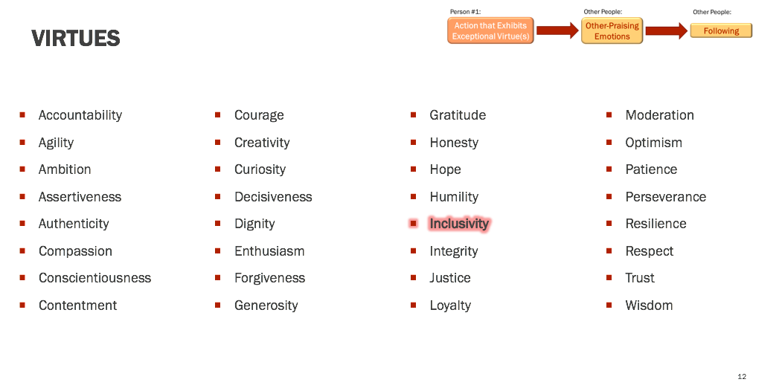

- Then, please include this table at least in one of the acitivity. You should change the words of the questions accordingly to the activity. For example, the 1, 2, 3 (it can be more than three actions) on the left can be the “ethical” actions from the activity.
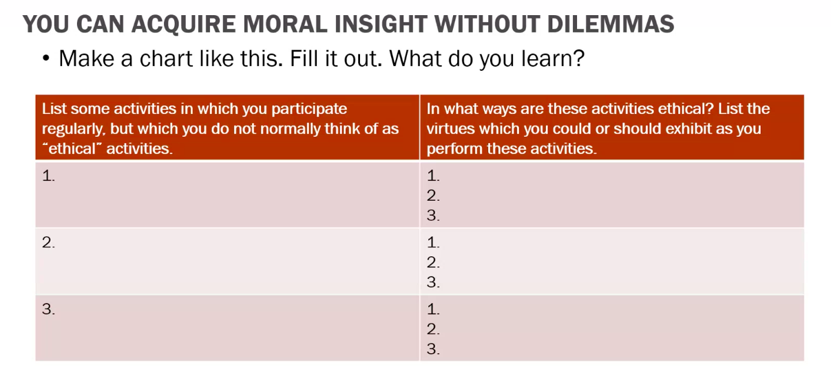
- Include this insight and creativity in one of the activity. Please change the word “CHANGE” “ADD” and “USE” to the actions according to the activity
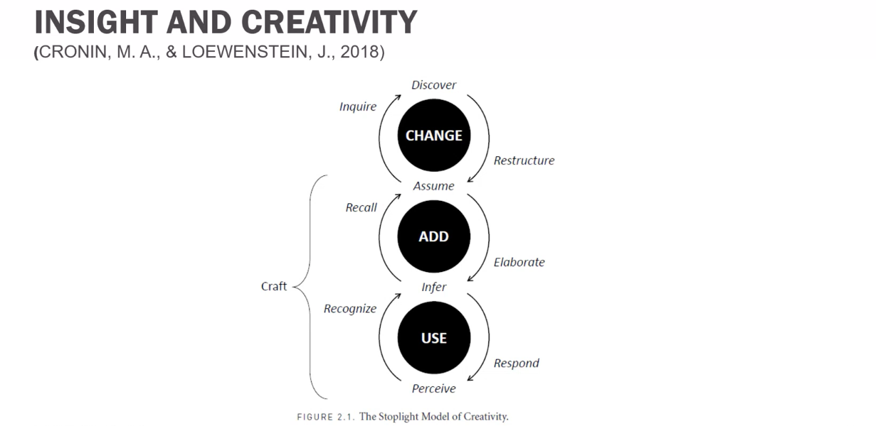
- Please add this chart to at least one of the activities. Change the word in each box according to the actions to that activity.

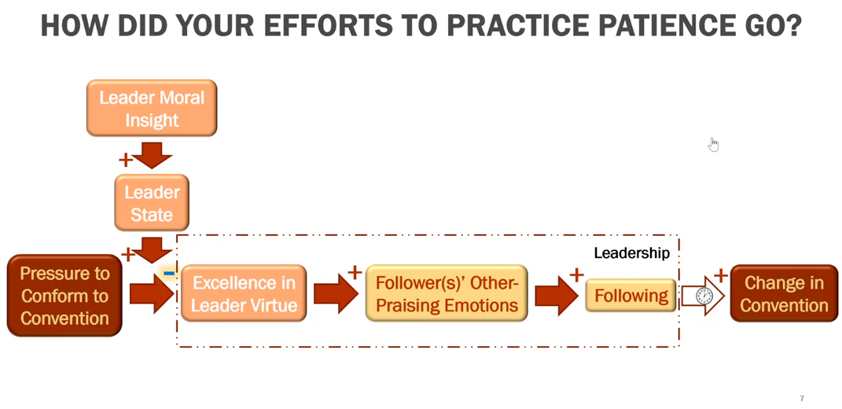

- Please include this chart to one activity. This is the same as the above one, but just a shorter version.


- Here are the citations that you should use and include in the paper, but just some of them:

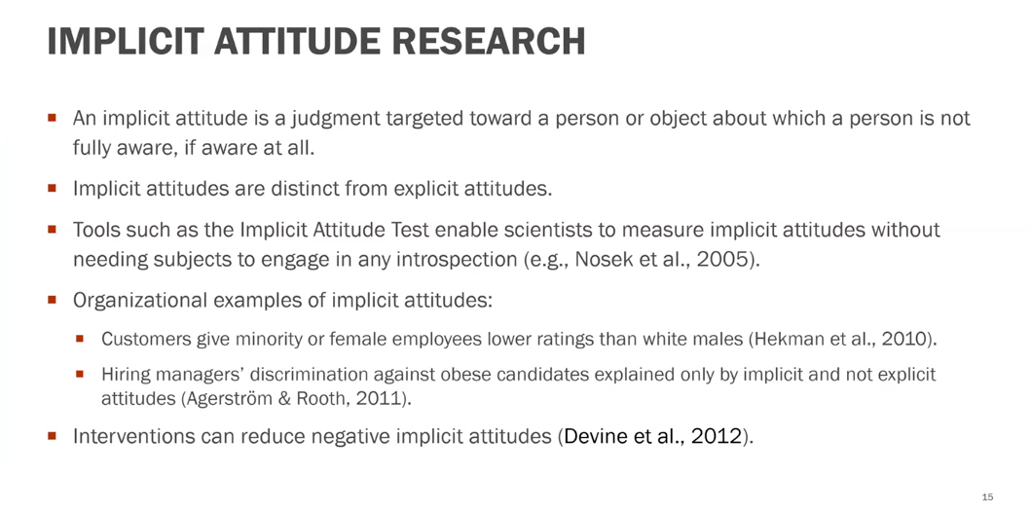


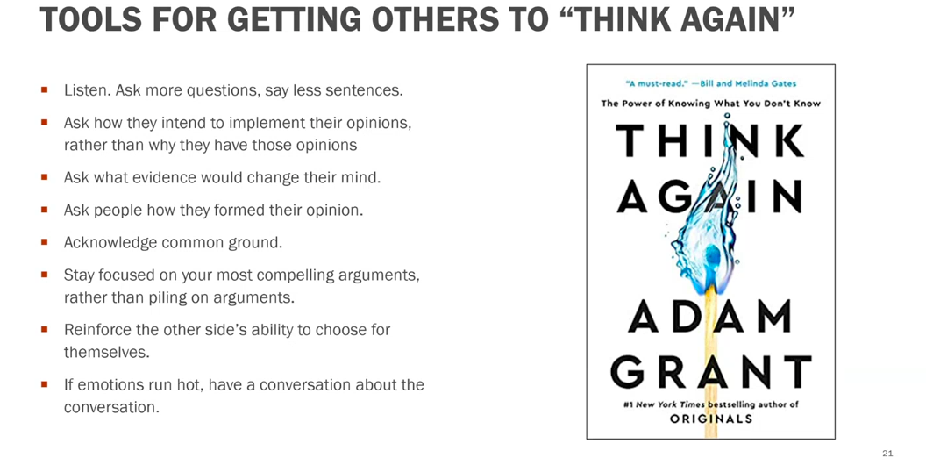
- This is a must citation that you have to use:

